https://www.hackerrank.com/challenges/kangaroo/problem

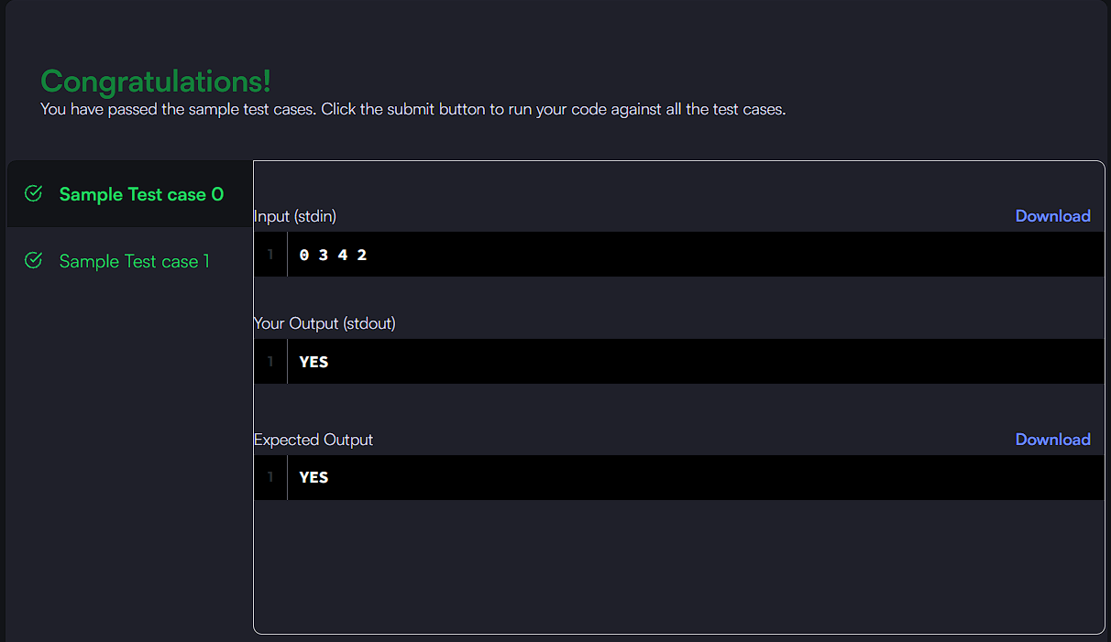
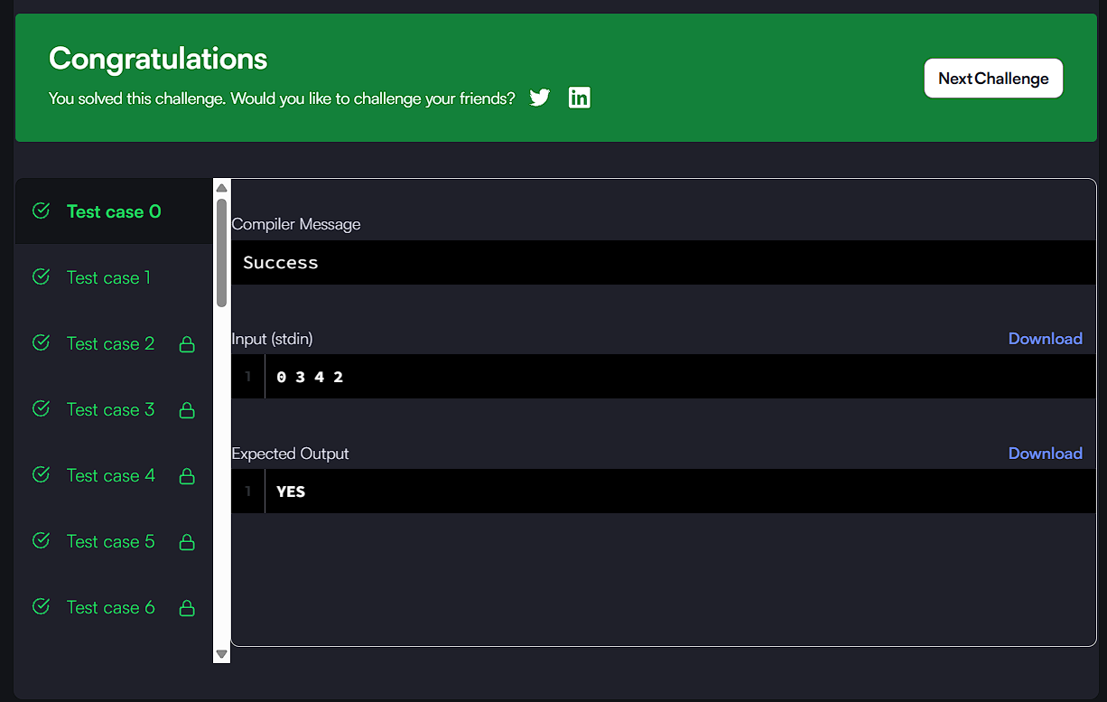

CODE:

if (v1 > v2 && (x2 - x1) % (v1 - v2) == 0) {
return "YES";
}
return "NO";

